Realm Playtests – Designer observations

Contents
Important context 1
24/10 2
Game 1; V-2.0.A 2
Game 2; V-2.0.A 2
07/11 3
Game 1; V-3.0.B 3
14/11 5
Game 1; V-4.0.A 5
Game 2; V-4.1.A 7
21/11 8
Game 1; V-5.0.A 8
05/12 10
Game 1; V-6.0.B 10
Game 1.5 (Extended); V-6.0.B 11
12/12 13
Game 1; V-7.0.A 13
Appendix A: Screenshots of messages 14

Important context

24/10

Game 1; V-2.0.A
N. of Players: 3
Game time: 12 minutes / 29 minutes
Result: Player 1 / 2 win due to military dominance.
Set up phase took longer than expected with players getting familiar with the rules. Feedback given was that the rules became intuitive after 2-3 turns of play.
The game should have ended at the 12 minute mark when Player 1 (in this case Fin) gained a Forest City on turn 4. This was accelerated based on a trade the previous turn.
The game continued on agreement of the players not to take said action. Game continued for a further 5 turns before player 2 reached a Military City. Player 3 obtained the city as the result of two successful trades for wood with the 'outside world' on their turn.
Player 2 also domineered the board. Having obtained soldiers first, they spent at least one action each turn to destroy opponent camps (except the winning turn). On all occasions bar one, Player 2 was able to win uncontested.
Player 2 also did not fail a check or wager roll. Charisma aided trading on 3 occasions.
Wrath did not effect the outcome of any wager. This includes for player 3 who selected 3 wrath upgrades.
Key points to take forward:
Charisma / trading rolls require a nerf.
Soldiers are currently a positive feedback loop and become a dominating strategy (bar maybe trade only).
Game is significantly faster with 3 players than 2.

Game 2; V-2.0.A
N. of players: 3
Game time: 5 minutes (abandoned due to workshop ending)
Forest rolls initially lead to 3 forests in a line ([2,2] [2,3] [2,4]).
This was not carried forward and the last one to be rolled [2,2] was rerolled.

07/11

Game 1; V-3.0.B
N. of players - 2
Game time - 20 minutes (game abandoned once feedback formulates as Neil needed to test with other groups).
Result - Player 1 clearly winning at point of abandonment, military dominance
See notes on commentary in ⁠playtest-feedback from Neil.
Game started slow with players familiarising with the rules. Kingdoms were placed on opposite sides of the board ([1,4] & [5,2]). Forests were at [4,5] and [2,2] (latter was not fully randomised).
Players did not upgrade structures as player 1 sought a strategy mainly to monopolise wood. Expansion was rapid when considered against game turns.
Player 1 gained soldiers first and went on to dominate the board via attacks. Out recruited player 2 to maintain a lead on soldiers by building more military camps earlier. 1st turn advantage was significant.
Player 2 was able to control both forests by turn 4 based on military advantage.
Trading was only used once. The trade failed. Trading was not considered viable in this game scenario.
Need to reduce randomisation in forest placements and institute limitations on kingdoms' distance to forests. Soldiers need to have some exhaust mechanism. If this is not done, military control appears to the the dominant strategy.
Game currently heavily regulated by positive feedback loops. This is not healthy for the 2 player version
Game very likely needs a bigger board for 3/4 players.

Game board from play test – taken in final game state
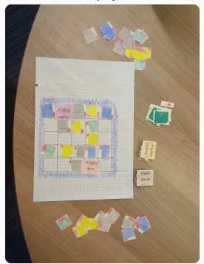
(B-tech board since main playtest version not at workshop)

14/11

Game 1; V-4.0.A
N of players - 3
Game time - 40 minutes
Result - Purple wins by citadel
Two of three forests spawned in the two closest squares to Brown Kingdom. The last forest spawned close to Red Kingdom. Kingdom Purple did not have access to forests.
Red played aggressive early game - additionally opting for grit and craftmanship to accelerate this fact. Purple played defensive in the early game with grit and wrath. Brown played somewhat defensively with charisma and wrath.
Brown and Red were eager to trade in the early game due to their abundances of wood and stone respectively. In absolute terms, Purple was providing more resources per trade - likely due to the known imbalance in forests.
Mid game - players have ended up trading multiple times per pass.
Late game - players have agreed to tentative truces. A forest city is the highest tier structure on the board, owned by Red. A couple of stuctures have reached town level. Purple has been hording resources during the peace. After trading for the final wood they need for the first action of their turn, they upgrade a town straight to a citadel with 25/25 using their final two action points on roughly turn 7 or 8. This was located in the corner of the board.
Grit was claimed at all possible instances (no forgotten turns).
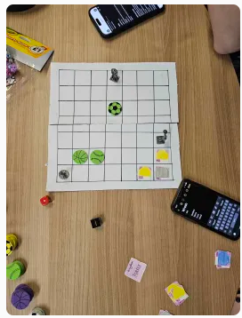
At roughly 40 min mark
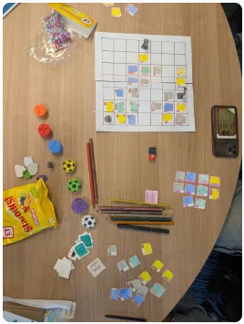

Game 2; V-4.1.A
N. of players - 4
Game time - 35 minutes. Game abandoned.
Result - Game abandoned with Brown and Red leading in the mid game.
Brown tried to place kingdom next to Orange - instituted hotfix.
RULE BOOK NEEDED ASAP - brown needed references to understand build and upgrade mechanics (particularly that territory can only be expanded to orthogonally adjacent squares).
Slight confusion over combat wagers - initially thought defence could exceed attack.
Confusion between designers over combat radius expansion. Amended in hotfix.
New players frequently forgetting grit & craftmanship bonuses.
Brown steamroll Orange in the mid game using 26 soldiers.
Red was building up a resource bank and was flying under the radar.

At ~15 minute mark
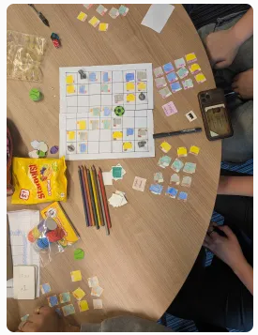

21/11

Game 1; V-5.0.A
N. of players 2
Game time - 55 minutes
Result - orange wins by lvl 4 civ
Player Brown - Wrath & craftmanship
Player Orange - Charisma & grit
Combat needs balancing - new meta to defend with only one soldier when cannot meet the attacking wager.
New player was less familiar with tracking resources and nearly forgot to claim a couple times.
Also attempted to hire soldiers multiple times in one turn.
Players we're frequently forgetting to declare resource type for external trade before rolling.
New players were confused by combat radius additional cost.
Paint card [denomination 2] were infrequently used.
Player orange upgraded from town to citadel on one turn.
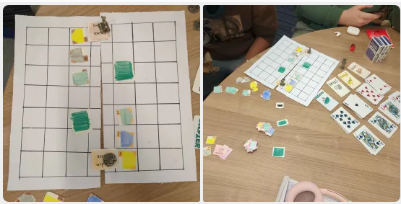

At the 25 minute point
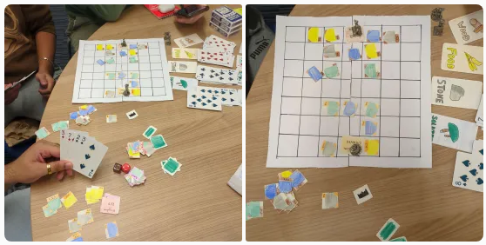
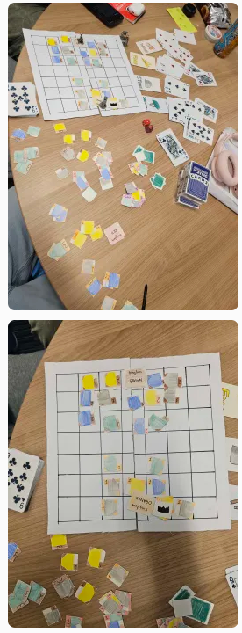
Game time 50 minutes

05/12

Game 1; V-6.0.B
N. of Players - 3
Game time - 15 minutes
Result - Player Red slays the Dragon.
Initial dash to expand towards the dragon, spreading structures towards forests and across the different rings.
Some players attempted to appease the dragon early on, realising that there was no benefit to wagering more than 1 soldier at a time in the early game.
While players Orange and Purple attempted to expand early on, player Red started upgrading early on with resources gained from trading. Alongside resources from the dragon, resource inflation appears to be appearing in the game.
Player Orange began early attacks on player Red based on the threat from the upgraded base, but failed.
Having rushed military strength, Player Red attacks the dragon with 20 soldiers on pass 4 reducing the health down to 6. Player red then expends their 3rd action point to attack the dragon again with their remaining 14 soldiers, slaying it. The dragon rolled 6 and 7 respectively.
Rolls were forgotten at the end of passes 1-3 for the anger gauge. Dragon needs buffs.
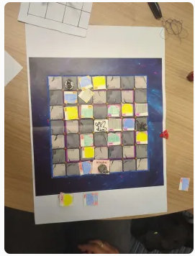
After the second pass.
End of the game
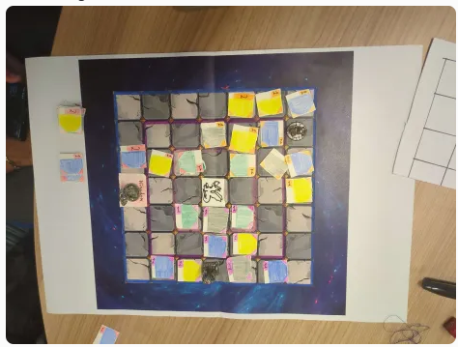

Game 1.5 (Extended); V-6.0.B
N of players - 3
Game time (total) - 28.5 minutes
Result - Player Purple wins by citadel
This playtest acted as a direct extension of the game from earlier in this workshop. As such, the dragon's health was effectively reset to 14 (15 - 1 overflow dmg from the previous kill) and it gained it's new dice for defence.
Player Red continued to work on their hyper-agro slay tactic for the next two passes of the game. This was stifled slightly by a hit of 10 defence by the dragon on a wager of 11 soldiers. Player Red most probably would have won on the next turn if Purple had not won earlier in the pass.
Player Orange continued to struggle as they appeared indecisive about the strategy they were employing. As a part of this, they continued to attack player Red depleting some number of soldiers, likely costing Red the game.
Player Purple continued to farm resources from structures and trading while maintaining minimal sufficient levels of military strength to deter agression. In addition to the tentative alliance against Player Red that held with Player Orange, Player Purple was able to secure enough resources to rush a citadel from their town mine to the right of their kingdom statue.
The game did not see as much setback on structures due to the early stages lacking the dragon attack rolls. In this context, this may have swung the game from Red to Purple in the later stages.
The dragon approaches appropriate stength with the new version, but may need a slight buff. This may be compensating for the missing dragon attacks.
Going all in on trading for soldiers and rushing the dragon is possibly going to be the new dominant strategy. This may need compensating for, but further testing is necessary on this front.
Generally though, the game feels like it is more fun to play and is less deadlocked.

12/12

Game 1; V-7.0.A
N. of players - 4
Game time (minus disruption) - 42 minutes
Result - Purple wins by citadel.
Players Red and Purple were new to the game and were advised based on the rulebook. Orange and Brown were played by designers.
Game critical issue - brown attempted to amass an army to fight the dragon off trades alone. At no point could any other players make a dent in the progress they were making.
Dragon roll forgotten once in 6 passes. One dragon roll did not trigger. 1 dragon roll landed on the dragon itself.
Trade rolls became dominant in the later stages of the game.
No player trades were attempted.
Board ended up very full by mid-game.
Trading needs a nerf
Image 1: mid-game approx 30 minutes in.
Image 2: after dragon attack end of pass 5.
Image 3: end of game, mid 7th pass
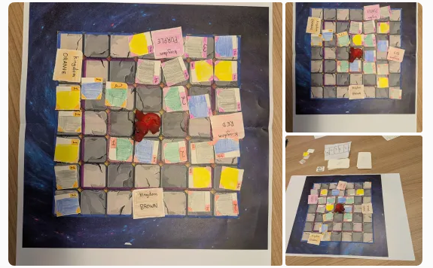

Appendix A: Screenshots of messages
